# **RETAIL SALES ANALYSIS**

We have been provided with a 7000+ electronics dataset consisting of various columns providing different information.

## **DATABASE DESIGN:**

| **id** |
| --- |
| **prices.amountMax** |
| **prices.amountMin** |
| **prices.availability** |
| **prices.condition** |
| **prices.currency** |
| **prices.dateSeen** |
| **prices.isSale** |
| **prices.merchant** |
| **prices.shipping** |
| **prices.sourceURLs** |
| **asins** |
| **brand** |
| **categories** |
| **dateAdded** |
| **dateUpdated** |
| **ean** |
| **imageURLs** |
| **keys** |
| **manufacturer** |
| **manufacturerNumber** |
| **name** |
| **primaryCategories** |
| **sourceURLs** |
| **upc** |
| **weight** |

## 

* The Database we have provided consists of 26 columns
* Through our analysis, we came to a conclusion that 10 columns are necessary for performing our queries.

## **DATABASE DESIGN AFTER ANALYSIS**

| **prices.amountMax** |
| --- |
| **prices.amountMin** |
| **prices.condition** |
| **prices.isSale** |
| **prices.merchant** |
| **brand** |
| **Date** |
| **name** |
| **primaryCategories** |

**Architecture diagram**

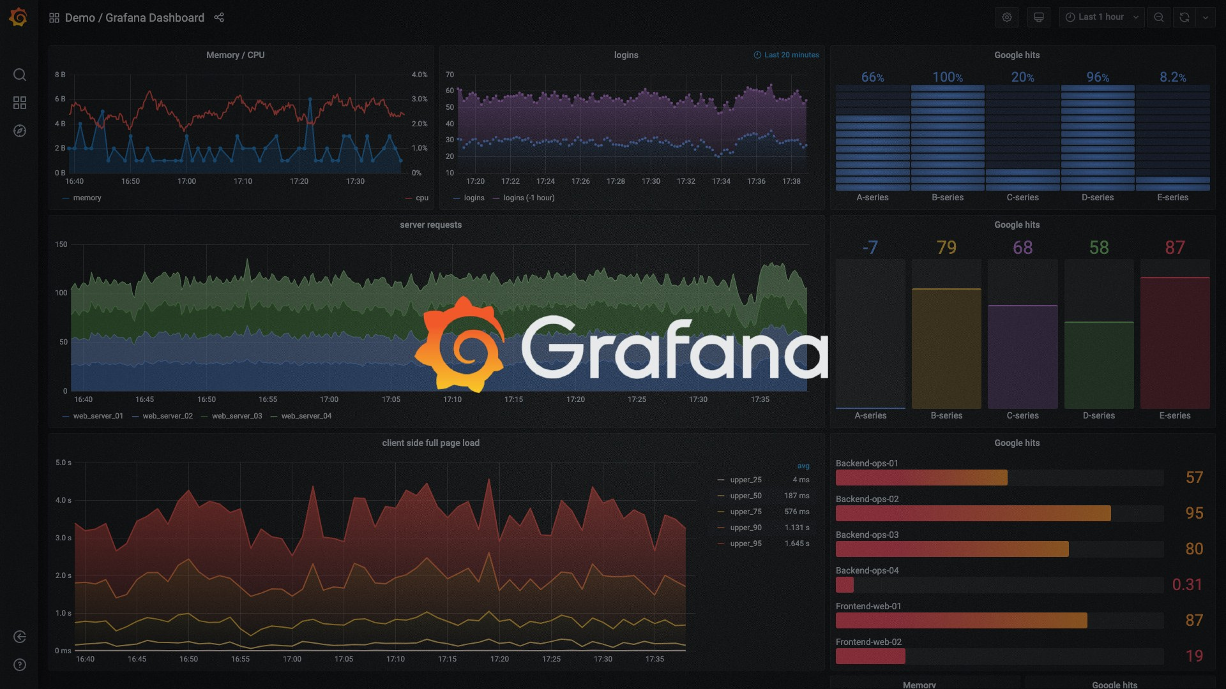



**UML Diagram**

**Class Diagram:**

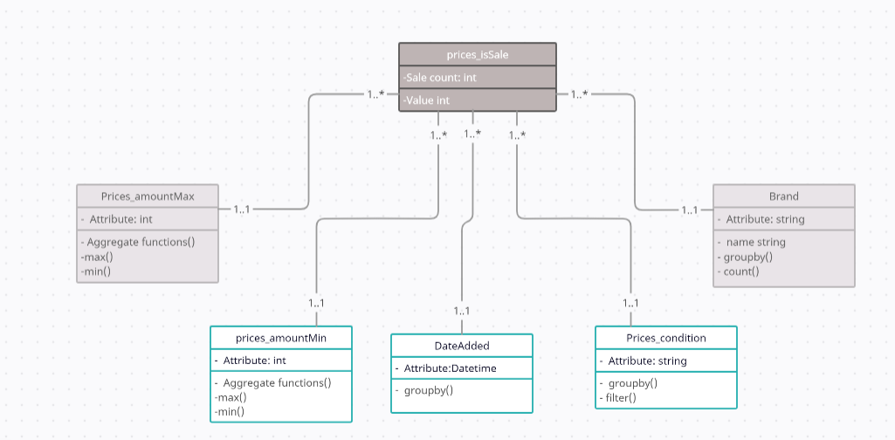

**Use case Diagram:**

